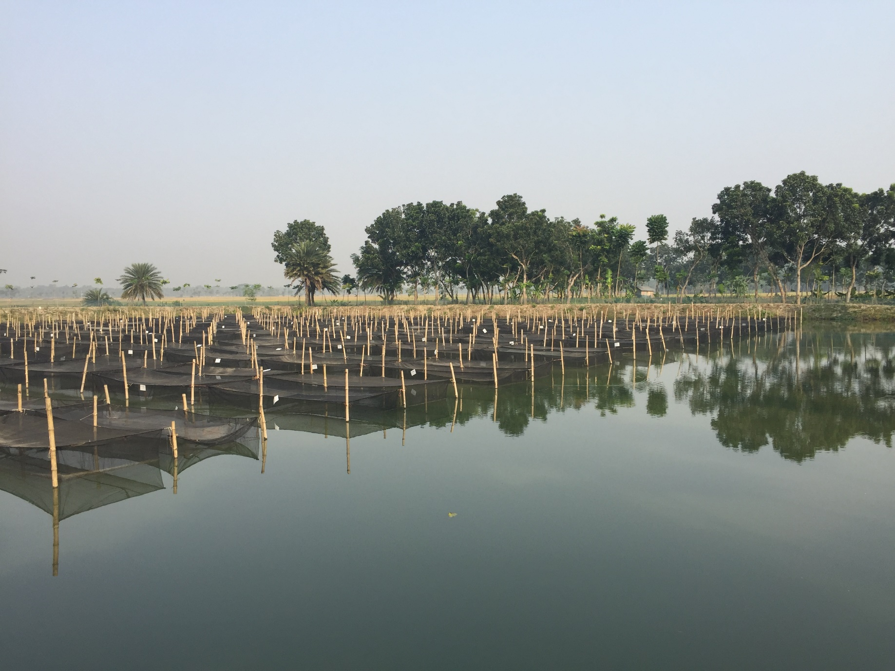 

April, 2021

AllocateMate: An R package for mate allocation

*Matthew G Hamilton*

th, Year>

<Report Title>

# <Report Sub-Title>

*<Author Name>*

April, 2021

AllocateMate: An R package for mate allocation

*Matthew G Hamilton*

th, Year>

<Report Title>

# <Report Sub-Title>

*<Author Name>*

April, 2021

AllocateMate: An R package for mate allocation

*Matthew G Hamilton*

th, Year>

<Report Title>

# <Report Sub-Title>

*<Author Name>*

April, 2021

AllocateMate: An R package for mate allocation

*Matthew G Hamilton*

th, Year>

<Report Title>

# <Report Sub-Title>

*<Author Name>*

April, 2021

AllocateMate: An R package for mate allocation

*Matthew G Hamilton*

th, Year>

<Report Title>

# <Report Sub-Title>

*<Author Name>*

April, 2021

AllocateMate: An R package for mate allocation

*Matthew G Hamilton*

th, Year>

<Report Title>

# <Report Sub-Title>

*<Author Name>*

April, 2021

AllocateMate: An R package for mate allocation

*Matthew G Hamilton*

th, Year>

<Report Title>

# <Report Sub-Title>

*<Author Name>*

April, 2021

AllocateMate: An R package for mate allocation

*Matthew G Hamilton*

th, Year>

<Report Title>

# <Report Sub-Title>

*<Author Name>*

April, 2021

AllocateMate: An R package for mate allocation

*Matthew G Hamilton*

th, Year>

<Report Title>

# <Report Sub-Title>

*<Author Name>*

April, 2021

AllocateMate: An R package for mate allocation

*Matthew G Hamilton*

th, Year>

<Report Title>

# <Report Sub-Title>

*<Author Name>*

April, 2021

AllocateMate: An R package for mate allocation

*Matthew G Hamilton*

th, Year>

<Report Title>

# <Report Sub-Title>

*<Author Name>*

April, 2021

AllocateMate: An R package for mate allocation

*Matthew G Hamilton*

th, Year>

<Report Title>

# <Report Sub-Title>

*<Author Name>*

April, 2021

AllocateMate: An R package for mate allocation

*Matthew G Hamilton*

th, Year>

<Report Title>

# <Report Sub-Title>

*<Author Name>*

April, 2021

AllocateMate: An R package for mate allocation

*Matthew G Hamilton*

th, Year>

<Report Title>

# <Report Sub-Title>

*<Author Name>*

April, 2021

AllocateMate: An R package for mate allocation

*Matthew G Hamilton*

th, Year>

<Report Title>

# <Report Sub-Title>

*<Author Name>*

April, 2021

AllocateMate: An R package for mate allocation

*Matthew G Hamilton*

th, Year>

<Report Title>

# <Report Sub-Title>

*<Author Name>*



### Citation

This publication should be cited as: Hamilton, MG. 2021. AllocateMate: An R package for mate allocation. Penang, Malaysia: CGIAR Research Program on Fish Agri-Food Systems. <Publication No>.

### About FISH

The [CGIAR Research Program on Fish Agri-Food Systems (FISH)](https://fish.cgiar.org/) is a multidisciplinary research program. Designed in collaboration with research partners, beneficiaries and stakeholders, FISH develops and implements research innovations that optimize the individual and joint contributions of aquaculture and small-scale fisheries to reducing poverty, improving food and nutrition security and sustaining the underlying natural resources and ecosystems services upon which both depend. The program is led by [WorldFish](https://www.worldfishcenter.org/), a member of the CGIAR Consortium. [CGIAR](http://www.cgiar.org/) is a global research partnership for a food secure future.

### Acknowledgments

Refer to [Fish Branding Guidelines](https://fish.cgiar.org/publications/fish-branding-guidelines) for acknowledgment, peer-review clause and disclaimer texts.

### Contact

WorldFish Communications and Marketing Department, Jalan Batu Maung, Batu Maung, 11960 Bayan Lepas, Penang, Malaysia. Email: [fish@cgiar.org](mailto:fish@cgiar.org)

### Creative Commons License



Content in this publication is licensed under a Creative Commons Attribution-NonCommercial 4.0 International License ([CC BY-NC 4.0](https://creativecommons.org/licenses/by-nc/4.0/)), which permits non-commercial use, including reproduction, adaptation and distribution of the publication provided the original work is properly cited.

© 2021 CGIAR Research Program on Fish Agri-Food Systems.

### Photo credits

Front cover, Matthew Hamilton.

### Disclaimer

Refer to [Fish Branding Guidelines](https://fish.cgiar.org/publications/fish-branding-guidelines) for acknowledgment, peer-review clause and disclaimer texts.

# Table of contents

1. Introduction 3

2. AllocateMate package 3

3. Installing AllocateMate 4

References 5

Annex 1. allocate.mate.ped function R help 6

Annex 2. allocate.mate.H function R help 9

# 1. Introduction

WorldFish manages multiple family-based genetic improvement programs for tilapia and carp species (Charo-Karisa et al., 2020; Hamilton et al., 2019a; Hamilton et al., 2019b; Hamilton et al., 2021; Hamzah et al., 2014). In family-based genetic improvement programs, mate allocation is a process whereby selected parents (or in some cases families) are allocated to mating pairs prior to a spawning event. Mating pairs are then crossed to produce next-generation families of known pedigree.

2

# 8

# Photo credit:

# 2. AllocateMate package

AllocateMate is a R package (R Core Team, 2020) comprised of two primary functions: *allocate.mate.ped* and *allocate.mate.H*. These functions allocate parents to mating pairs based on genetic relationships provided by the user in the form a pedigree file (*allocate.mate.ped*) or a relationship matrix (*allocate.mate.H*). These functions generate mating lists, using a linear programing approach (Berkelaar, 2020):

* to minimise the average Wright’s inbreeding coefficient (*F*; Wright, 1922) of offspring, by minimising the average coefficient of coancestry between parents in mating pairs; or
* according to assortative mating principles (Saura et al., 2017), by maximising the standard deviation of the parental mean EBVs of mating pairs.

Inputs, outputs and examples of use for the *allocate.mate.ped* and *allocate.mate.H* functionsare detailed in Annex 1 and Annex 2.

# 3. Application in tilapia

To ensure tilapia successfully spawn in a timely fashion, it is common practice to place multiple females with one male in a mating hapa/tank (Trong, 2013). To use AllocateMate in this circumstance, the following guidelines can be adopted.

If females in each mating hapa/tank are to be from a single full-sibling family:

* the *allocate.mate.ped* function should be used (Annex 1);
* female parental identifiers (i.e. ID’s present in the ‘parents’ data frame; Annex 1) should be modified so that there is only one female parental ID per mating hapa/tank, each representing multiple females from the same family; and
* N_AS_PARENT in the ‘parents’ data frame (Annex 1) should be specified as 1.

If females in each mating hapa/tank are to be from multiple families and the average Wright’s inbreeding coefficient is to be minimised (i.e. method = "min_F"; Annex 1 and Annex 2):

* for males, N_AS_PARENT should be specified as the number of females to be placed in the hapa/tank with the male;
* for females, N_AS_PARENT should be specified as 1.

If females in each mating hapa/tank are to be from multiple families and assortative mating principles are to be applied (i.e. method = "assortative"; Annex 1 and Annex 2), to ensure that the female parents with the highest EBVs are not placed in the same mating hapa/tank:

* female parents should be sorted by their estimated breeding value (EBV; Annex 1 and Annex 2) and divided into groups – individuals with the highest EBVs should be grouped together, etc. The number of groups should equal the number of females in each mating hapa/tank and groups should be of equal size;
* N_AS_PARENT should be specified as 1; and
* *allocate.mate.ped* or *allocate.mate.H* should be run separately for each group of females with a common group of males; and
* the mating lists from all groups should be combined upon completion.

# 4. Installing AllocateMate

AllocateMate Version 1.0 is available at <https://github.com/mghamilton/AllocateMate> or for download as a .tar.gz **‘**source file**’** (provide link). To install the package from the .tar.gz source file:

* use the *install.packages* function **in R** – install.packages(*path****-****to****-****source****-file***, repos = NULL, type="source"); or
* within R studio, go to Tools -> Install Packages and then set ‘Install From’ to ‘Package Archive File (.zip; .tar.gz)’ before browsing to find the downloaded .tar.gz file.

# References

Berkelaar, M., 2020. Package ‘lpSolve’. Version 5.6.15. CRAN. <https://cran.uib.no/web/packages/lpSolve/lpSolve.pdf>.

Charo-Karisa, H., Ali, S., Marijani, E., Ibrahim, N.A., Trinh, T.Q., Chadag, M.V., Benzie, J.A., 2020. Genetic parameters for black spot disease (diplopstomiasis) caused by Uvulifer sp. infection in Nile tilapia (*Oreochromis niloticus* L.). Aquaculture. 532, 736039. <https://doi.org/10.1016/j.aquaculture.2020.736039>

Hamilton, M.G., Mekkawy, W., Benzie, J.A.H., 2019a. Sibship assignment to the founders of a Bangladeshi *Catla catla* breeding population. Genetics Selection Evolution. 51, 17. <https://doi.org/10.1186/s12711-019-0454-x>

Hamilton, M.G., Mekkawy, W., Kilian, A., Benzie, J.A.H., 2019b. Single Nucleotide Polymorphisms (SNPs) reveal sibship among founders of a Bangladeshi rohu (*Labeo rohita*) breeding population. Front Genet. 10. <https://doi.org/10.3389/fgene.2019.00597>

Hamilton, M.G., Mekkawy, W., Barman, B.K., Alam, M.B., Karim, M., Benzie, J.A.H., 2021. Genetic relationships among founders of a silver carp (*Hypophthalmichthys molitrix*) genetic improvement program in Bangladesh. Aquaculture, 736715. <https://doi.org/https://doi.org/10.1016/j.aquaculture.2021.736715>

Hamzah, A., Ponzoni, R.W., Nguyen, N.H., Khaw, H.L., Yee, H.Y., Mohd Nor, S.A., 2014. Performance of the Genetically Improved Farmed Tilapia (GIFT) strain over ten generations of selection in Malaysia. Pertanika J Trop Agric Sci. 37, 411-429

R Core Team, 2020. R: A language and environment for statistical computing. R Foundation for Statistical Computing, Vienna, Austria.

Saura, M., Villanueva, B., Fernández, J., Toro, M.A., 2017. Effect of assortative mating on genetic gain and inbreeding in aquaculture selective breeding programs. Aquaculture. 472, 30-37. <https://doi.org/10.1016/j.aquaculture.2016.05.013>

Trong, T., 2013. Optimisation of selective breeding program for Nile tilapia (*Oreochromis niloticus*).

Wright, S., 1922. Coefficients of inbreeding and relationship. Am Nat. 56, 330-338

# Annex 1. allocate.mate.ped function R help

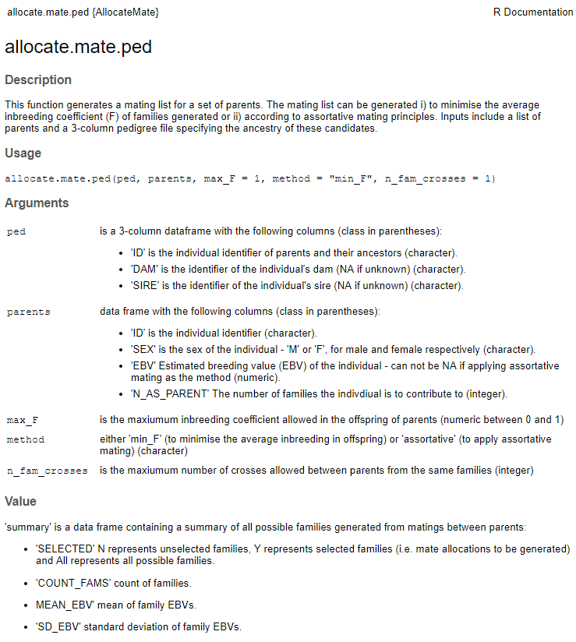 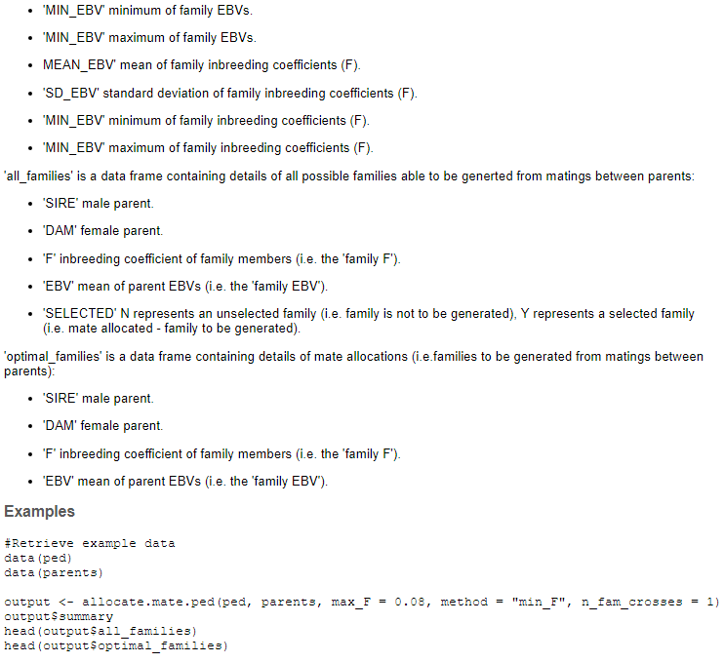



# Annex 2. allocate.mate.H function R help

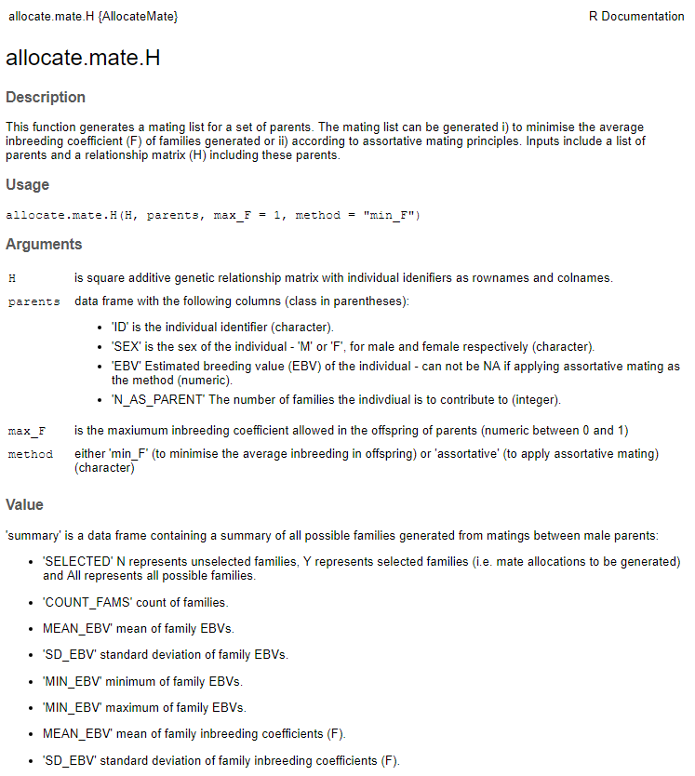

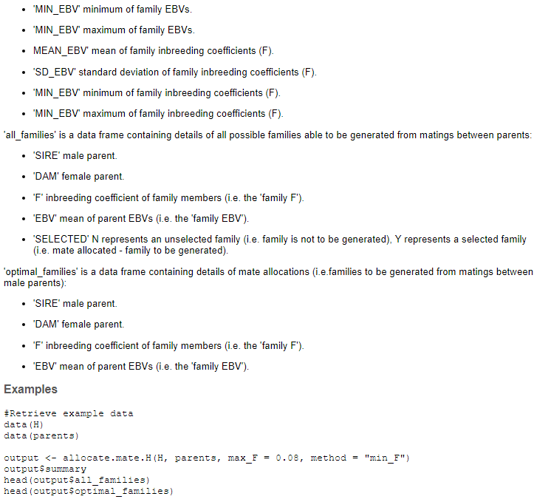





**About FISH**

### The [CGIAR Research Program on Fish Agri-Food Systems (FISH)](https://fish.cgiar.org/) is a multidisciplinary research program. Designed in collaboration with research partners, beneficiaries and stakeholders, FISH develops and implements research innovations that optimize the individual and joint contributions of aquaculture and small-scale fisheries to reducing poverty, improving food and nutrition security and sustaining the underlying natural resources and ecosystems services upon which both depend. The program is led by [WorldFish](https://www.worldfishcenter.org/), a member of the CGIAR Consortium. [CGIAR](http://www.cgiar.org/) is a global research partnership for a food secure future.

For more information, please visit [fish.cgiar.org](http://fish.cgiar.org/)

**About FISH**

### The [CGIAR Research Program on Fish Agri-Food Systems (FISH)](https://fish.cgiar.org/) is a multidisciplinary research program. Designed in collaboration with research partners, beneficiaries and stakeholders, FISH develops and implements research innovations that optimize the individual and joint contributions of aquaculture and small-scale fisheries to reducing poverty, improving food and nutrition security and sustaining the underlying natural resources and ecosystems services upon which both depend. The program is led by [WorldFish](https://www.worldfishcenter.org/), a member of the CGIAR Consortium. [CGIAR](http://www.cgiar.org/) is a global research partnership for a food secure future.

For more information, please visit [fish.cgiar.org](http://fish.cgiar.org/)

**About FISH**

### The [CGIAR Research Program on Fish Agri-Food Systems (FISH)](https://fish.cgiar.org/) is a multidisciplinary research program. Designed in collaboration with research partners, beneficiaries and stakeholders, FISH develops and implements research innovations that optimize the individual and joint contributions of aquaculture and small-scale fisheries to reducing poverty, improving food and nutrition security and sustaining the underlying natural resources and ecosystems services upon which both depend. The program is led by [WorldFish](https://www.worldfishcenter.org/), a member of the CGIAR Consortium. [CGIAR](http://www.cgiar.org/) is a global research partnership for a food secure future.

For more information, please visit [fish.cgiar.org](http://fish.cgiar.org/)

**About FISH**

### The [CGIAR Research Program on Fish Agri-Food Systems (FISH)](https://fish.cgiar.org/) is a multidisciplinary research program. Designed in collaboration with research partners, beneficiaries and stakeholders, FISH develops and implements research innovations that optimize the individual and joint contributions of aquaculture and small-scale fisheries to reducing poverty, improving food and nutrition security and sustaining the underlying natural resources and ecosystems services upon which both depend. The program is led by [WorldFish](https://www.worldfishcenter.org/), a member of the CGIAR Consortium. [CGIAR](http://www.cgiar.org/) is a global research partnership for a food secure future.

For more information, please visit [fish.cgiar.org](http://fish.cgiar.org/)

**About FISH**

### The [CGIAR Research Program on Fish Agri-Food Systems (FISH)](https://fish.cgiar.org/) is a multidisciplinary research program. Designed in collaboration with research partners, beneficiaries and stakeholders, FISH develops and implements research innovations that optimize the individual and joint contributions of aquaculture and small-scale fisheries to reducing poverty, improving food and nutrition security and sustaining the underlying natural resources and ecosystems services upon which both depend. The program is led by [WorldFish](https://www.worldfishcenter.org/), a member of the CGIAR Consortium. [CGIAR](http://www.cgiar.org/) is a global research partnership for a food secure future.

For more information, please visit [fish.cgiar.org](http://fish.cgiar.org/)

**About FISH**

### The [CGIAR Research Program on Fish Agri-Food Systems (FISH)](https://fish.cgiar.org/) is a multidisciplinary research program. Designed in collaboration with research partners, beneficiaries and stakeholders, FISH develops and implements research innovations that optimize the individual and joint contributions of aquaculture and small-scale fisheries to reducing poverty, improving food and nutrition security and sustaining the underlying natural resources and ecosystems services upon which both depend. The program is led by [WorldFish](https://www.worldfishcenter.org/), a member of the CGIAR Consortium. [CGIAR](http://www.cgiar.org/) is a global research partnership for a food secure future.

For more information, please visit [fish.cgiar.org](http://fish.cgiar.org/)

**About FISH**

### The [CGIAR Research Program on Fish Agri-Food Systems (FISH)](https://fish.cgiar.org/) is a multidisciplinary research program. Designed in collaboration with research partners, beneficiaries and stakeholders, FISH develops and implements research innovations that optimize the individual and joint contributions of aquaculture and small-scale fisheries to reducing poverty, improving food and nutrition security and sustaining the underlying natural resources and ecosystems services upon which both depend. The program is led by [WorldFish](https://www.worldfishcenter.org/), a member of the CGIAR Consortium. [CGIAR](http://www.cgiar.org/) is a global research partnership for a food secure future.

For more information, please visit [fish.cgiar.org](http://fish.cgiar.org/)

**About FISH**

### The [CGIAR Research Program on Fish Agri-Food Systems (FISH)](https://fish.cgiar.org/) is a multidisciplinary research program. Designed in collaboration with research partners, beneficiaries and stakeholders, FISH develops and implements research innovations that optimize the individual and joint contributions of aquaculture and small-scale fisheries to reducing poverty, improving food and nutrition security and sustaining the underlying natural resources and ecosystems services upon which both depend. The program is led by [WorldFish](https://www.worldfishcenter.org/), a member of the CGIAR Consortium. [CGIAR](http://www.cgiar.org/) is a global research partnership for a food secure future.

For more information, please visit [fish.cgiar.org](http://fish.cgiar.org/)

**About FISH**

### The [CGIAR Research Program on Fish Agri-Food Systems (FISH)](https://fish.cgiar.org/) is a multidisciplinary research program. Designed in collaboration with research partners, beneficiaries and stakeholders, FISH develops and implements research innovations that optimize the individual and joint contributions of aquaculture and small-scale fisheries to reducing poverty, improving food and nutrition security and sustaining the underlying natural resources and ecosystems services upon which both depend. The program is led by [WorldFish](https://www.worldfishcenter.org/), a member of the CGIAR Consortium. [CGIAR](http://www.cgiar.org/) is a global research partnership for a food secure future.

For more information, please visit [fish.cgiar.org](http://fish.cgiar.org/)

**About FISH**

### The [CGIAR Research Program on Fish Agri-Food Systems (FISH)](https://fish.cgiar.org/) is a multidisciplinary research program. Designed in collaboration with research partners, beneficiaries and stakeholders, FISH develops and implements research innovations that optimize the individual and joint contributions of aquaculture and small-scale fisheries to reducing poverty, improving food and nutrition security and sustaining the underlying natural resources and ecosystems services upon which both depend. The program is led by [WorldFish](https://www.worldfishcenter.org/), a member of the CGIAR Consortium. [CGIAR](http://www.cgiar.org/) is a global research partnership for a food secure future.

For more information, please visit [fish.cgiar.org](http://fish.cgiar.org/)

**About FISH**

### The [CGIAR Research Program on Fish Agri-Food Systems (FISH)](https://fish.cgiar.org/) is a multidisciplinary research program. Designed in collaboration with research partners, beneficiaries and stakeholders, FISH develops and implements research innovations that optimize the individual and joint contributions of aquaculture and small-scale fisheries to reducing poverty, improving food and nutrition security and sustaining the underlying natural resources and ecosystems services upon which both depend. The program is led by [WorldFish](https://www.worldfishcenter.org/), a member of the CGIAR Consortium. [CGIAR](http://www.cgiar.org/) is a global research partnership for a food secure future.

For more information, please visit [fish.cgiar.org](http://fish.cgiar.org/)

**About FISH**

### The [CGIAR Research Program on Fish Agri-Food Systems (FISH)](https://fish.cgiar.org/) is a multidisciplinary research program. Designed in collaboration with research partners, beneficiaries and stakeholders, FISH develops and implements research innovations that optimize the individual and joint contributions of aquaculture and small-scale fisheries to reducing poverty, improving food and nutrition security and sustaining the underlying natural resources and ecosystems services upon which both depend. The program is led by [WorldFish](https://www.worldfishcenter.org/), a member of the CGIAR Consortium. [CGIAR](http://www.cgiar.org/) is a global research partnership for a food secure future.

For more information, please visit [fish.cgiar.org](http://fish.cgiar.org/)

**About FISH**

### The [CGIAR Research Program on Fish Agri-Food Systems (FISH)](https://fish.cgiar.org/) is a multidisciplinary research program. Designed in collaboration with research partners, beneficiaries and stakeholders, FISH develops and implements research innovations that optimize the individual and joint contributions of aquaculture and small-scale fisheries to reducing poverty, improving food and nutrition security and sustaining the underlying natural resources and ecosystems services upon which both depend. The program is led by [WorldFish](https://www.worldfishcenter.org/), a member of the CGIAR Consortium. [CGIAR](http://www.cgiar.org/) is a global research partnership for a food secure future.

For more information, please visit [fish.cgiar.org](http://fish.cgiar.org/)

**About FISH**

### The [CGIAR Research Program on Fish Agri-Food Systems (FISH)](https://fish.cgiar.org/) is a multidisciplinary research program. Designed in collaboration with research partners, beneficiaries and stakeholders, FISH develops and implements research innovations that optimize the individual and joint contributions of aquaculture and small-scale fisheries to reducing poverty, improving food and nutrition security and sustaining the underlying natural resources and ecosystems services upon which both depend. The program is led by [WorldFish](https://www.worldfishcenter.org/), a member of the CGIAR Consortium. [CGIAR](http://www.cgiar.org/) is a global research partnership for a food secure future.

For more information, please visit [fish.cgiar.org](http://fish.cgiar.org/)

**About FISH**

### The [CGIAR Research Program on Fish Agri-Food Systems (FISH)](https://fish.cgiar.org/) is a multidisciplinary research program. Designed in collaboration with research partners, beneficiaries and stakeholders, FISH develops and implements research innovations that optimize the individual and joint contributions of aquaculture and small-scale fisheries to reducing poverty, improving food and nutrition security and sustaining the underlying natural resources and ecosystems services upon which both depend. The program is led by [WorldFish](https://www.worldfishcenter.org/), a member of the CGIAR Consortium. [CGIAR](http://www.cgiar.org/) is a global research partnership for a food secure future.

For more information, please visit [fish.cgiar.org](http://fish.cgiar.org/)

**About FISH**

### The [CGIAR Research Program on Fish Agri-Food Systems (FISH)](https://fish.cgiar.org/) is a multidisciplinary research program. Designed in collaboration with research partners, beneficiaries and stakeholders, FISH develops and implements research innovations that optimize the individual and joint contributions of aquaculture and small-scale fisheries to reducing poverty, improving food and nutrition security and sustaining the underlying natural resources and ecosystems services upon which both depend. The program is led by [WorldFish](https://www.worldfishcenter.org/), a member of the CGIAR Consortium. [CGIAR](http://www.cgiar.org/) is a global research partnership for a food secure future.

For more information, please visit [fish.cgiar.org](http://fish.cgiar.org/)